**Spring-Rest-Handson**

**# Hands on 1 Create a Spring Web Project using Maven**

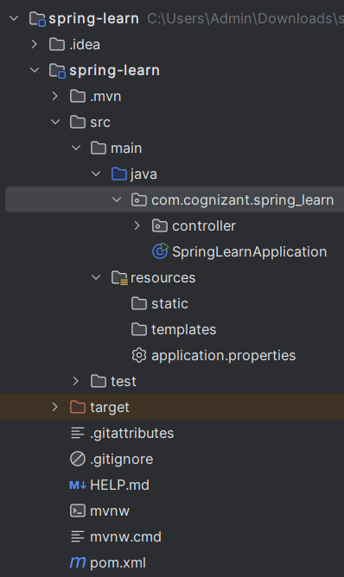

**## pom.xml**

<?xml version="1.0" encoding="UTF-8"?>  
<project xmlns="http://maven.apache.org/POM/4.0.0" xmlns:xsi="http://www.w3.org/2001/XMLSchema-instance"  
 xsi:schemaLocation="http://maven.apache.org/POM/4.0.0 https://maven.apache.org/xsd/maven-4.0.0.xsd">  
 <modelVersion>4.0.0</modelVersion>

<parent>  
 <groupId>org.springframework.boot</groupId>  
 <artifactId>spring-boot-starter-parent</artifactId>  
 <version>3.5.3</version>  
 <relativePath/> <!-- lookup parent from repository -->  
 </parent>  
 <groupId>com.cognizant</groupId>  
 <artifactId>spring-learn</artifactId>  
 <version>0.0.1-SNAPSHOT</version>  
 <name>spring-learn</name>  
 <description>Demo project for Spring Boot</description>  
 <url/>  
 <licenses>  
 <license/>  
 </licenses>  
 <developers>  
 <developer/>  
 </developers>  
 <scm>  
 <connection/>  
 <developerConnection/>  
 <tag/>  
 <url/>  
 </scm>  
 <properties>  
 <java.version>24</java.version>  
 </properties>  
 <dependencies>  
 <dependency>  
 <groupId>org.springframework.boot</groupId>  
 <artifactId>spring-boot-starter-web</artifactId>  
 </dependency>  
  
 <dependency>  
 <groupId>org.springframework.boot</groupId>  
 <artifactId>spring-boot-devtools</artifactId>  
 <scope>runtime</scope>  
 <optional>true</optional>  
 </dependency>  
 <dependency>  
 <groupId>org.springframework.boot</groupId>  
 <artifactId>spring-boot-starter-test</artifactId>  
 <scope>test</scope>  
 </dependency>  
 </dependencies>  
 <build>  
 <plugins>  
 <plugin>  
 <groupId>org.springframework.boot</groupId>  
 <artifactId>spring-boot-maven-plugin</artifactId>  
 </plugin>  
 </plugins>  
 </build>  
</project>

**# com.cognizant.spring_learn.SpringLearnApplication.java**

package com.cognizant.spring_learn;  
  
import org.springframework.boot.SpringApplication;  
import org.springframework.boot.autoconfigure.SpringBootApplication;  
  
@SpringBootApplication  
public class SpringLearnApplication {  
  
 public static void main(String[] args) {  
 SpringApplication.*run*(SpringLearnApplication.class, args);  
 System.*out*.println("SpringLearnApplication started successfully!");  
 }  
}

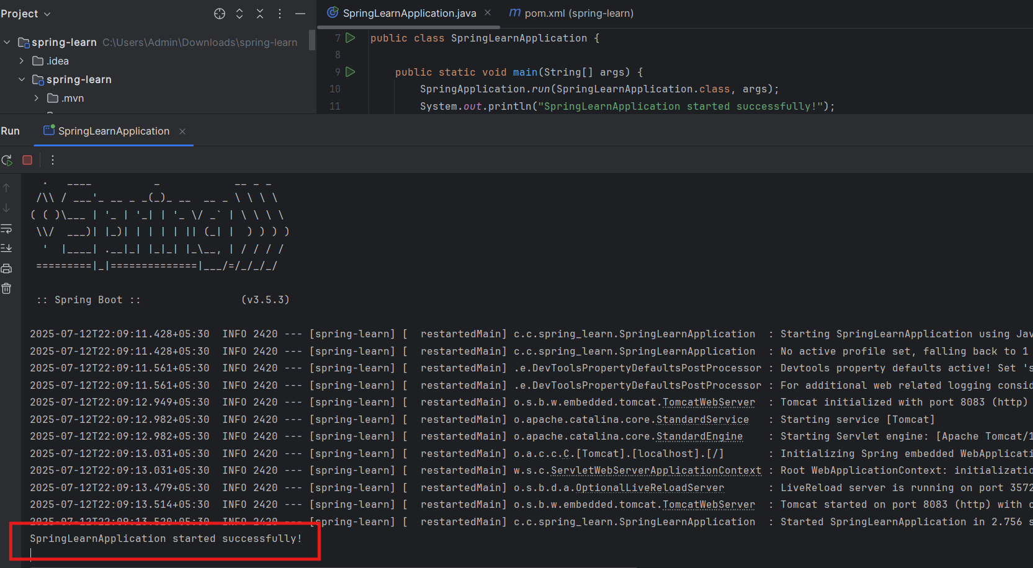**## Output**

**# Purpose of @SpringBootApplication annotation**

A single @SpringBootApplication annotation can be used to enable those three features, that is:

* @EnableAutoConfiguration: enable [Spring Boot’s auto-configuration mechanism](https://docs.spring.io/spring-boot/docs/2.1.0.RELEASE/reference/html/using-boot-auto-configuration.html)
* @ComponentScan: enable @Component scan on the package where the application is located
* @Configuration: allow to register extra beans in the context or import additional configuration classes

**# Hands on 4 Spring Core – Load Country from Spring Configuration XML**

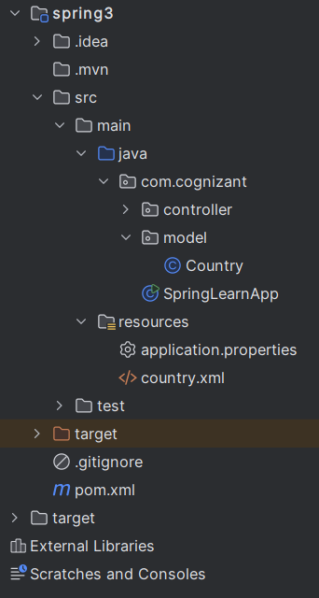

**## pom.xml**

<project xmlns="http://maven.apache.org/POM/4.0.0" xmlns:xsi="http://www.w3.org/2001/XMLSchema-instance"  
 xsi:schemaLocation="http://maven.apache.org/POM/4.0.0 http://maven.apache.org/xsd/maven-4.0.0.xsd">  
 <modelVersion>4.0.0</modelVersion>  
  
 <groupId>com.cognizant</groupId>  
 <artifactId>spring3</artifactId>  
 <version>1.0-SNAPSHOT</version>  
 <packaging>jar</packaging>  
  
 <name>spring3</name>

<url>http://maven.apache.org</url>  
  
 <properties>  
 <project.build.sourceEncoding>UTF-8</project.build.sourceEncoding>  
 </properties>  
  
  
 <dependencies>  
 <dependency>  
 <groupId>org.springframework.boot</groupId>  
 <artifactId>spring-boot-starter</artifactId>  
 <version>3.5.0</version>  
 </dependency>  
  
 <dependency>  
 <groupId>org.springframework</groupId>  
 <artifactId>spring-context</artifactId>  
 <version>6.2.7</version>  
 </dependency>  
 <dependency>  
 <groupId>junit</groupId>  
 <artifactId>junit</artifactId>  
 <version>3.8.1</version>  
 <scope>test</scope>  
 </dependency>  
 </dependencies>  
</project>

**## com.cognizant.model.Country.java**

package com.cognizant.model;  
  
import org.slf4j.Logger;  
import org.slf4j.LoggerFactory;  
  
public class Country {  
 private static final Logger *LOGGER* = LoggerFactory.*getLogger*(Country.class);  
 String code;  
 String name;  
  
 public Country(){  
 *LOGGER*.debug("country constructor called by bean");  
 }  
  
 public String getCode() {  
 *LOGGER*.debug("Inside getCode()");  
 return code;  
 }  
  
 public void setCode(String code) {  
 *LOGGER*.debug("Inside setCode()");  
 this.code = code;  
 }  
  
 public String getName() {  
 *LOGGER*.debug("Inside getName()");  
 return name;  
 }  
  
 public void setName(String name) {  
 *LOGGER*.debug("Inside setName()");  
 this.name = name;  
 }  
  
 @Override  
 public String toString() {  
 return "Country{" +  
 "code='" + code + '\'' +  
 ", name='" + name + '\'' +  
 '}';  
 }  
}

**## resources.country.xml**

<?xml version="1.0" encoding="UTF-8"?>  
<beans xmlns="http://www.springframework.org/schema/beans"  
 xmlns:xsi="http://www.w3.org/2001/XMLSchema-instance"  
 xsi:schemaLocation="http://www.springframework.org/schema/beans http://www.springframework.org/schema/beans/spring-beans.xsd">  
  
 <bean id = "country" class="com.cognizant.model.Country">  
 <property name="code" value="IN"></property>  
 <property name="name" value="India"></property>  
 </bean>  
</beans>

**## com.cognizant.SpringLearnApp.java**

package com.cognizant;  
import com.cognizant.model.Country;  
import org.slf4j.Logger;  
import org.slf4j.LoggerFactory;  
import org.springframework.boot.SpringApplication;  
import org.springframework.boot.autoconfigure.SpringBootApplication;  
import org.springframework.context.ApplicationContext;  
import org.springframework.context.annotation.ImportResource;  
  
  
@SpringBootApplication  
@ImportResource("classpath:country.xml")  
public class SpringLearnApp {  
 private static final Logger *LOGGER* = LoggerFactory.*getLogger*(SpringLearnApp.class);  
  
 public static void main(String[] args) {  
 ApplicationContext context = SpringApplication.*run*(SpringLearnApp.class, args);  
 *displayCountry*(context);  
 }  
  
 public static void displayCountry(ApplicationContext context) {  
 Country country = context.getBean("country", Country.class);  
 *LOGGER*.info("Country: {}", country);  
 }  
  
}

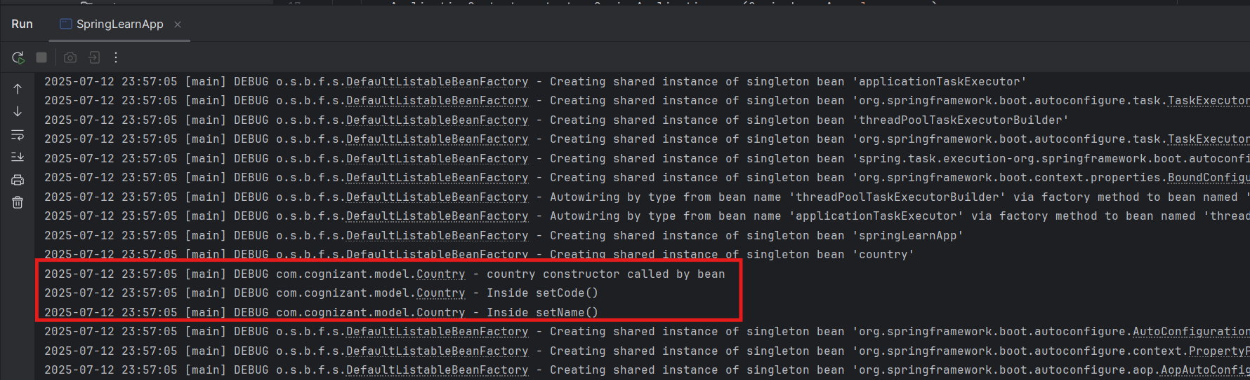**## Output**

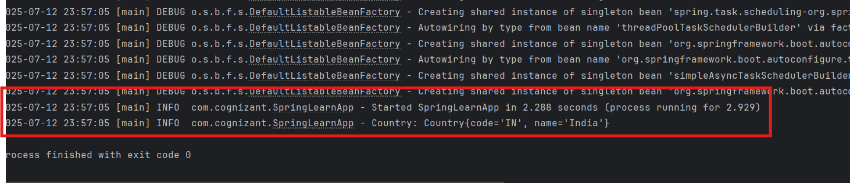

**## ApplicationContext**

* Core interface in Spring for accessing the container.
* Maintains all beans defined in the configuration.
* Supports advanced features like internationalization, event propagation, etc.

**## ClassPathXmlApplicationContext**

* Concrete implementation of ApplicationContext which loads XML configuration from the classpath.

**## context.getBean("country", Country.class)**

* Spring **reads the XML**, **instantiates the bean**, **injects values using setters**, and **returns the object**.
* In this case, it:
  1. Calls constructor of Country
  2. Sets code = IN and name = India using setters
  3. Returns the fully initialized Country object

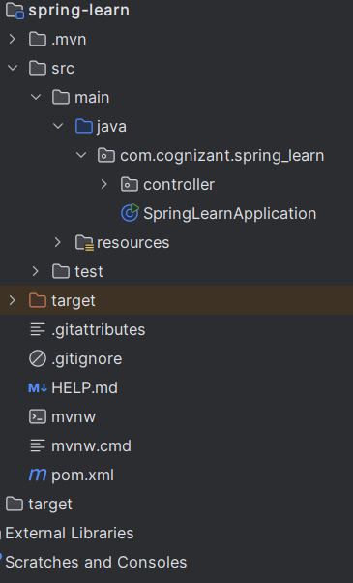**# Hello World RESTful Web Service**

**## pom.xml**

<?xml version="1.0" encoding="UTF-8"?>  
<project xmlns="http://maven.apache.org/POM/4.0.0" xmlns:xsi="http://www.w3.org/2001/XMLSchema-instance"  
 xsi:schemaLocation="http://maven.apache.org/POM/4.0.0 https://maven.apache.org/xsd/maven-4.0.0.xsd">  
 <modelVersion>4.0.0</modelVersion>  
 <parent>  
 <groupId>org.springframework.boot</groupId>  
 <artifactId>spring-boot-starter-parent</artifactId>  
 <version>3.5.3</version>  
 <relativePath/> <!-- lookup parent from repository -->  
 </parent>  
 <groupId>com.cognizant</groupId>  
 <artifactId>spring-learn</artifactId>  
 <version>0.0.1-SNAPSHOT</version>  
 <name>spring-learn</name>  
 <description>Demo project for Spring Boot</description>  
 <url/>  
 <licenses>  
 <license/>  
 </licenses>  
 <developers>  
 <developer/>  
 </developers>  
 <scm>  
 <connection/>  
 <developerConnection/>  
 <tag/>  
 <url/>  
 </scm>  
 <properties>  
 <java.version>24</java.version>  
 </properties>  
 <dependencies>  
 <dependency>  
 <groupId>org.springframework.boot</groupId>  
 <artifactId>spring-boot-starter-web</artifactId>  
 </dependency>  
  
 <dependency>  
 <groupId>org.springframework.boot</groupId>  
 <artifactId>spring-boot-devtools</artifactId>  
 <scope>runtime</scope>  
 <optional>true</optional>  
 </dependency>  
 <dependency>  
 <groupId>org.springframework.boot</groupId>  
 <artifactId>spring-boot-starter-test</artifactId>  
 <scope>test</scope>  
 </dependency>  
 </dependencies>  
  
 <build>  
 <plugins>  
 <plugin>  
 <groupId>org.springframework.boot</groupId>  
 <artifactId>spring-boot-maven-plugin</artifactId>  
 </plugin>  
 </plugins>  
 </build>  
  
</project>

**## com.cognizant.spring_learn.controller.HelloController.java**

package com.cognizant.spring_learn.controller;  
  
import org.slf4j.Logger;  
import org.slf4j.LoggerFactory;  
import org.springframework.web.bind.annotation.GetMapping;  
import org.springframework.web.bind.annotation.RestController;  
  
@RestController  
public class HelloController {  
  
 private static final Logger *logger* = LoggerFactory.*getLogger*(HelloController.class);  
  
 @GetMapping("/hello")  
 public String sayHello(){  
  
 *logger*.info("Start");  
 String s= "Hello World !!";  
 *logger*.info("end");  
 return s;  
 }  
}

**## com.cognizant.spring_learn.controller.SpringLearnApplication.java**

package com.cognizant.spring_learn;  
  
import org.springframework.boot.SpringApplication;  
import org.springframework.boot.autoconfigure.SpringBootApplication;  
  
@SpringBootApplication  
public class SpringLearnApplication {  
  
 public static void main(String[] args) {  
 SpringApplication.*run*(SpringLearnApplication.class, args);  
 System.*out*.println("SpringLearnApplication started successfully!");  
 }  
  
}

**## resources.application.properties**

spring.application.name=spring-learn  
server.port = 8083

**## Output**

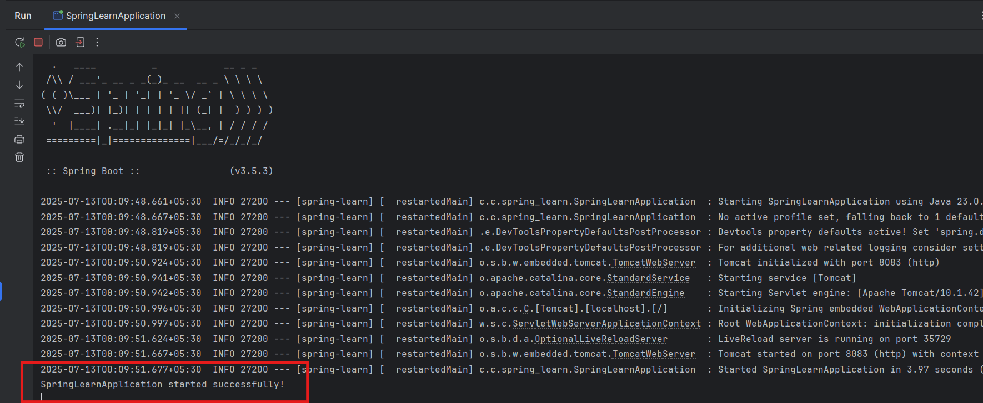

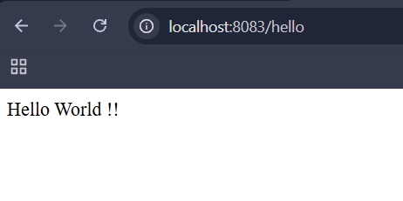

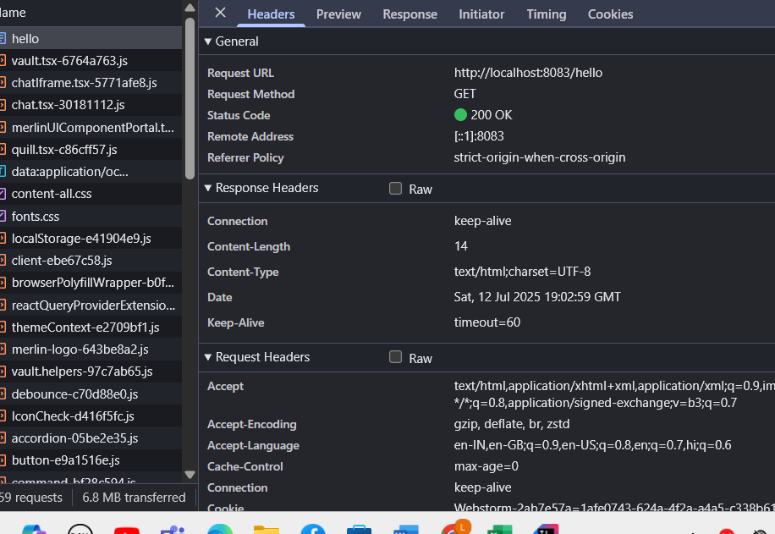

**# REST - Country Web Service**

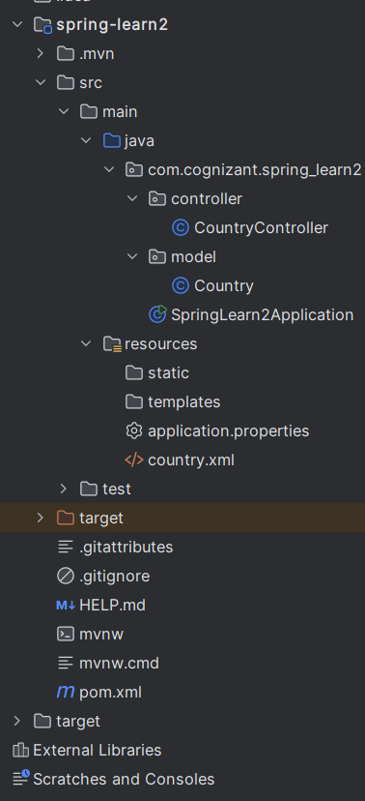

**## pom.xml**

<?xml version="1.0" encoding="UTF-8"?>  
<project xmlns="http://maven.apache.org/POM/4.0.0" xmlns:xsi="http://www.w3.org/2001/XMLSchema-instance"  
 xsi:schemaLocation="http://maven.apache.org/POM/4.0.0 https://maven.apache.org/xsd/maven-4.0.0.xsd">  
 <modelVersion>4.0.0</modelVersion>  
 <parent>  
 <groupId>org.springframework.boot</groupId>  
 <artifactId>spring-boot-starter-parent</artifactId>  
 <version>3.5.3</version>  
 <relativePath/> <!-- lookup parent from repository -->  
 </parent>  
 <groupId>com.cognizant</groupId>  
 <artifactId>spring-learn2</artifactId>  
 <version>0.0.1-SNAPSHOT</version>  
 <name>spring-learn2</name>  
 <description>Demo project for Spring Boot</description>  
 <url/>  
 <licenses>  
 <license/>  
 </licenses>  
 <developers>  
 <developer/>  
 </developers>  
 <scm>  
 <connection/>  
 <developerConnection/>  
 <tag/>  
 <url/>  
 </scm>  
 <properties>  
 <java.version>24</java.version>  
 </properties>  
 <dependencies>  
 <dependency>  
 <groupId>org.springframework.boot</groupId>  
 <artifactId>spring-boot-starter-web</artifactId>  
 </dependency>  
  
 <dependency>  
 <groupId>org.springframework.boot</groupId>  
 <artifactId>spring-boot-devtools</artifactId>  
 <scope>runtime</scope>  
 <optional>true</optional>  
 </dependency>  
 <dependency>  
 <groupId>com.mysql</groupId>  
 <artifactId>mysql-connector-j</artifactId>  
 <scope>runtime</scope>  
 </dependency>  
 <dependency>  
 <groupId>org.springframework.boot</groupId>  
 <artifactId>spring-boot-starter-test</artifactId>  
 <scope>test</scope>  
 </dependency>  
 </dependencies>  
  
 <build>  
 <plugins>  
 <plugin>  
 <groupId>org.springframework.boot</groupId>  
 <artifactId>spring-boot-maven-plugin</artifactId>  
 </plugin>  
 </plugins>  
 </build>  
  
</project>

**## com.cognizant.spring_learn2.model.Country.java**

package com.cognizant.spring_learn2.model;  
  
import org.slf4j.Logger;  
import org.slf4j.LoggerFactory;  
  
public class Country {  
  
 private String code ;  
 private String name;  
  
 public String getCode() {  
 return code;  
 }  
  
 public void setCode(String code) {  
 this.code = code;  
 }  
  
 public String getName() {  
 return name;  
 }  
  
 public void setName(String name) {  
 this.name = name;  
 }  
 @Override  
 public String toString() {  
 return "Country{" +  
 "code='" + code + '\'' +  
 ", name='" + name + '\'' +  
 '}';  
 }  
}

**## com.cognizant.spring_learn2.controller.CountryController.java**

package com.cognizant.spring_learn2.controller;  
  
import com.cognizant.spring_learn2.model.Country;  
import org.springframework.context.ApplicationContext;  
import org.springframework.context.support.ClassPathXmlApplicationContext;  
import org.springframework.web.bind.annotation.GetMapping;  
import org.springframework.web.bind.annotation.RequestMapping;  
import org.springframework.web.bind.annotation.RestController;  
  
@RestController  
@RequestMapping("/")  
public class CountryController {  
 ApplicationContext context = new ClassPathXmlApplicationContext("country.xml");  
  
 Country country = (Country)context.getBean("country");  
  
 @GetMapping("/country")  
 public Country getCountryIndia(){  
 return country;  
 }  
}

**## com.cognizant.spring_learn2.SpringLearn2Application.java**

package com.cognizant.spring_learn2;  
  
import org.springframework.boot.SpringApplication;  
import org.springframework.boot.autoconfigure.SpringBootApplication;  
  
@SpringBootApplication  
public class SpringLearn2Application {  
  
 public static void main(String[] args) {  
 SpringApplication.*run*(SpringLearn2Application.class, args);  
 }  
}

**## resources.country.xml**

<?xml version="1.0" encoding="UTF-8"?>  
<beans xmlns="http://www.springframework.org/schema/beans"  
 xmlns:xsi="http://www.w3.org/2001/XMLSchema-instance"  
 xsi:schemaLocation="  
 http://www.springframework.org/schema/beans http://www.springframework.org/schema/beans/spring-beans.xsd">  
  
 <!-- bean definitions here -->  
 <bean id="country" class="com.cognizant.spring_learn2.model.Country">  
 <property name="code" value="IN" />  
 <property name="name" value="India" />  
 </bean>  
</beans>

**## resources.application.properties**

spring.application.name=spring-learn2  
server.port = 8083

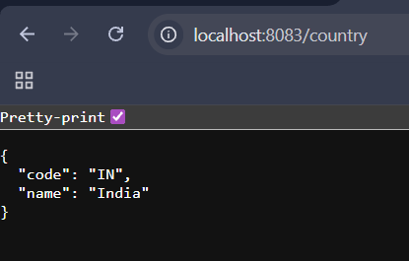**## Output**

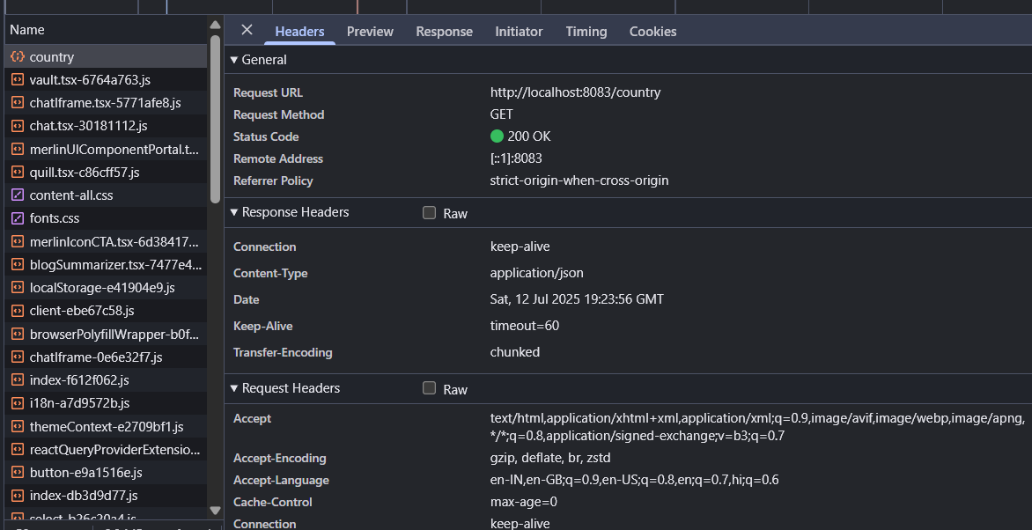

**# REST - Get country based on country code**

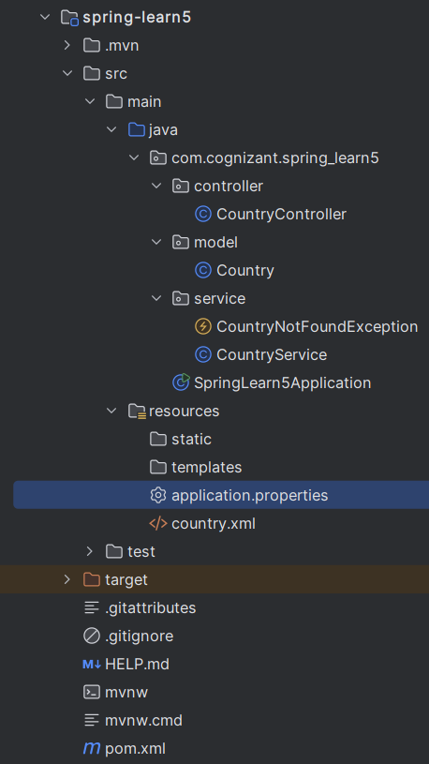

**## resources.application.properties**

spring.application.name=spring-learn5  
server.port=8083

**## pom.xml**

<?xml version="1.0" encoding="UTF-8"?>  
<project xmlns="http://maven.apache.org/POM/4.0.0" xmlns:xsi="http://www.w3.org/2001/XMLSchema-instance"  
 xsi:schemaLocation="http://maven.apache.org/POM/4.0.0 https://maven.apache.org/xsd/maven-4.0.0.xsd">  
 <modelVersion>4.0.0</modelVersion>  
 <parent>  
 <groupId>org.springframework.boot</groupId>  
 <artifactId>spring-boot-starter-parent</artifactId>  
 <version>3.5.3</version>  
 <relativePath/> <!-- lookup parent from repository -->  
 </parent>  
 <groupId>com.cognizant</groupId>  
 <artifactId>spring-learn5</artifactId>  
 <version>0.0.1-SNAPSHOT</version>  
 <name>spring-learn5</name>  
 <description>Demo project for Spring Boot</description>  
 <url/>  
 <licenses>  
 <license/>  
 </licenses>  
 <developers>  
 <developer/>  
 </developers>  
 <scm>  
 <connection/>  
 <developerConnection/>  
 <tag/>  
 <url/>  
 </scm>  
 <properties>  
 <java.version>17</java.version>  
 </properties>  
 <dependencies>  
 <dependency>  
 <groupId>org.springframework.boot</groupId>  
 <artifactId>spring-boot-starter-security</artifactId>  
 </dependency>  
 <dependency>  
 <groupId>org.springframework.boot</groupId>  
 <artifactId>spring-boot-starter-web</artifactId>  
 </dependency>  
  
 <dependency>  
 <groupId>org.springframework.boot</groupId>  
 <artifactId>spring-boot-devtools</artifactId>  
 <scope>runtime</scope>  
 <optional>true</optional>  
 </dependency>  
 <dependency>  
 <groupId>org.springframework.boot</groupId>  
 <artifactId>spring-boot-starter-test</artifactId>  
 <scope>test</scope>  
 </dependency>   
 </dependencies>  
  
 <build>  
 <plugins>  
 <plugin>  
 <groupId>org.springframework.boot</groupId>  
 <artifactId>spring-boot-maven-plugin</artifactId>  
 </plugin>  
 </plugins>  
 </build>  
  
</project>

**## resources.country.xml**

<?xml version="1.0" encoding="UTF-8"?>  
<beans xmlns="http://www.springframework.org/schema/beans"  
 xmlns:context="http://www.springframework.org/schema/context"  
 xmlns:xsi="http://www.w3.org/2001/XMLSchema-instance"  
 xsi:schemaLocation="http://www.springframework.org/schema/beans  
 https://www.springframework.org/schema/beans/spring-beans.xsd  
 http://www.springframework.org/schema/context  
 https://www.springframework.org/schema/context/spring-context.xsd">  
  
 <bean id="countryList" class="java.util.ArrayList">  
 <constructor-arg>  
 <list>  
 <bean class="com.cognizant.spring_learn5.model.Country">  
 <property name="code" value="IN"/>  
 <property name="name" value="India"/>  
 </bean>  
 <bean class="com.cognizant.spring_learn5.model.Country">  
 <property name="code" value="US"/>  
 <property name="name" value="United States"/>  
 </bean>  
 <bean class="com.cognizant.spring_learn5.model.Country">  
 <property name="code" value="DE"/>  
 <property name="name" value="Germany"/>  
 </bean>  
 <bean class="com.cognizant.spring_learn5.model.Country">  
 <property name="code" value="JP"/>  
 <property name="name" value="Japan"/>  
 </bean>  
 </list>  
 </constructor-arg>  
 </bean>  
</beans>

**## com.cognizant.spring_learn5.model.Country.java**

package com.cognizant.spring_learn5.model;  
  
public class Country {  
 String code;  
 String name;  
   
 public Country() {}  
 public Country(String code, String name) {  
 this.code = code;  
 this.name = name;  
 }  
 public String getCode() {  
 return code;  
 }  
 public void setCode(String code) {  
 this.code = code;  
 }  
 public String getName() {  
 return name;  
 }  
 public void setName(String name) {  
 this.name = name;  
 }  
}

**## com.cognizant.spring_learn5.controller.CountryController.java**

package com.cognizant.spring_learn5.controller;  
  
import com.cognizant.spring_learn5.model.Country;  
import com.cognizant.spring_learn5.service.CountryNotFoundException;  
import com.cognizant.spring_learn5.service.CountryService;  
import org.springframework.beans.factory.annotation.Autowired;  
import org.springframework.web.bind.annotation.GetMapping;  
import org.springframework.web.bind.annotation.PathVariable;  
import org.springframework.web.bind.annotation.RestController;  
  
@RestController  
public class CountryController {  
 @Autowired  
 private CountryService countryService;  
  
 @GetMapping("/countries/{code}")  
 public Country getCountry(@PathVariable String code) throws CountryNotFoundException {  
 return countryService.getCountry(code);  
 }  
}

**## com.cognizant.spring_learn5.service.CountryService.java**

package com.cognizant.spring_learn5.service;  
  
import com.cognizant.spring_learn5.model.Country;  
import org.springframework.beans.factory.annotation.Autowired;  
import org.springframework.context.ApplicationContext;  
import org.springframework.stereotype.Service;  
  
import java.util.List;  
  
@Service  
public class CountryService {  
 @Autowired  
 private ApplicationContext context;  
  
 public Country getCountry(String code) throws CountryNotFoundException {  
 List<Country> countryList = context.getBean("countryList", List.class);  
  
 return countryList.stream()  
 .filter(c -> c.getCode().equalsIgnoreCase(code))  
 .findFirst()  
 .orElseThrow(() -> new CountryNotFoundException("Country not found with code: " + code));  
 }  
}

**## com.cognizant.spring_learn5.service.CountryNotFoundException.java**

package com.cognizant.spring_learn5.service;  
  
public class CountryNotFoundException extends Exception{  
 public CountryNotFoundException(String message) {  
 super(message);  
 }  
}

**## com.cognizant.spring_learn5.SpringLearn5Application.java**

package com.cognizant.spring_learn5;  
  
import org.springframework.boot.SpringApplication;  
import org.springframework.boot.autoconfigure.SpringBootApplication;  
import org.springframework.context.annotation.ImportResource;  
  
@SpringBootApplication  
@ImportResource("classpath:country.xml")  
public class SpringLearn5Application {  
  
 public static void main(String[] args) {  
 SpringApplication.*run*(SpringLearn5Application.class, args);  
 }  
}

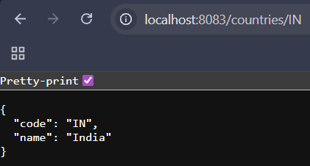**## Output**

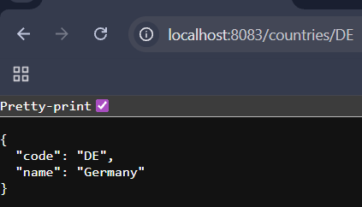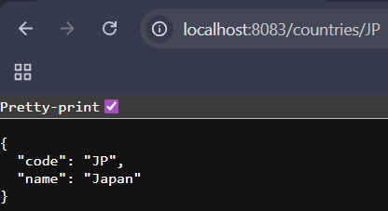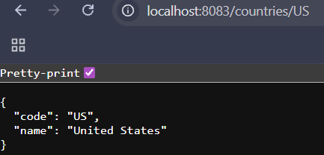

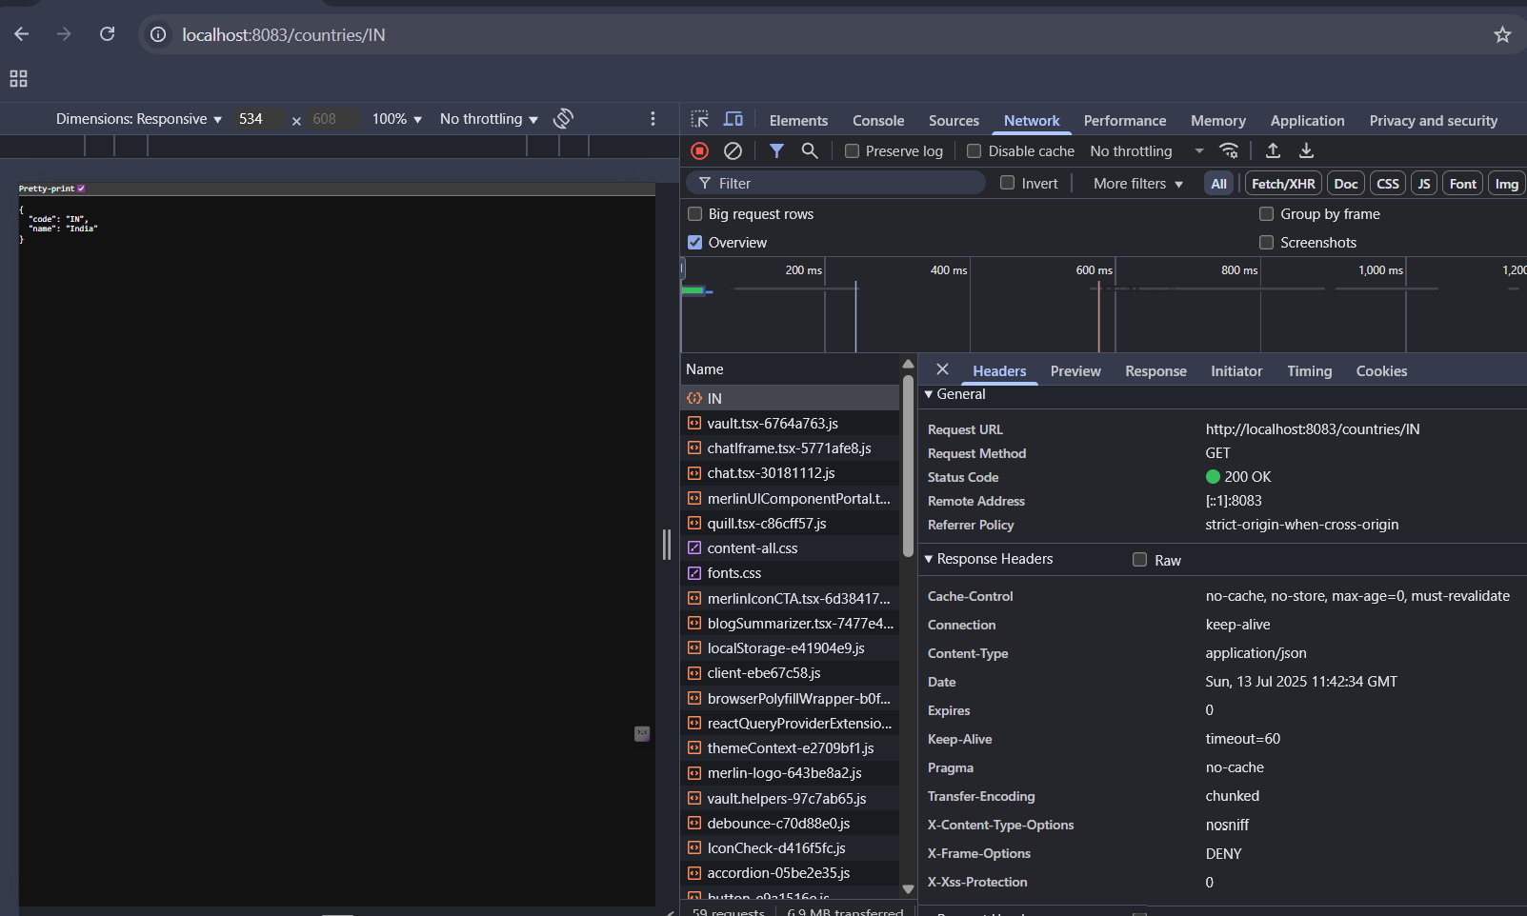

**JWT-handson**

**# Create authentication service that returns JWT**

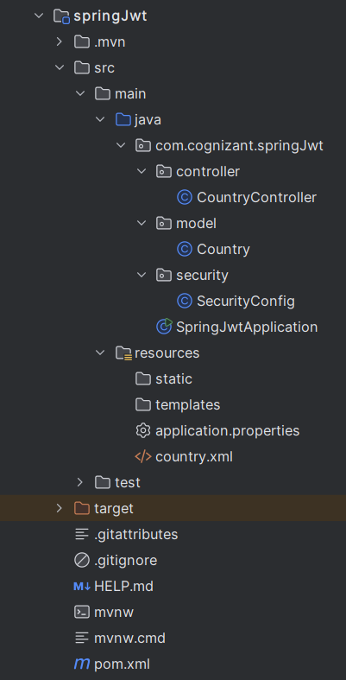

**## resources.application.properties**

spring.application.name=springJwt  
server.port = 8090

**## pom.xml**

<?xml version="1.0" encoding="UTF-8"?>  
<project xmlns="http://maven.apache.org/POM/4.0.0" xmlns:xsi="http://www.w3.org/2001/XMLSchema-instance"  
 xsi:schemaLocation="http://maven.apache.org/POM/4.0.0 https://maven.apache.org/xsd/maven-4.0.0.xsd">  
 <modelVersion>4.0.0</modelVersion>  
 <parent>  
 <groupId>org.springframework.boot</groupId>  
 <artifactId>spring-boot-starter-parent</artifactId>  
 <version>2.6.6</version>  
 <relativePath/> <!-- lookup parent from repository -->  
 </parent>  
 <groupId>com.cognizant</groupId>  
 <artifactId>springJwt</artifactId>  
 <version>0.0.1-SNAPSHOT</version>  
 <name>springJwt</name>  
 <description>Demo project for Spring Boot</description>  
 <url/>  
 <licenses>  
 <license/>  
 </licenses>  
 <developers>  
 <developer/>  
 </developers>  
 <scm>  
 <connection/>  
 <developerConnection/>  
 <tag/>  
 <url/>  
 </scm>  
 <properties>  
 <java.version>17</java.version>  
 </properties>  
 <dependencies>  
 <dependency>  
 <groupId>org.springframework.boot</groupId>  
 <artifactId>spring-boot-starter-security</artifactId>  
 </dependency>  
 <dependency>  
 <groupId>org.springframework.boot</groupId>  
 <artifactId>spring-boot-starter-web</artifactId>  
 </dependency>  
  
 <dependency>  
 <groupId>org.springframework.boot</groupId>  
 <artifactId>spring-boot-devtools</artifactId>  
 <scope>runtime</scope>  
 <optional>true</optional>  
 </dependency>  
 <dependency>  
 <groupId>org.springframework.boot</groupId>  
 <artifactId>spring-boot-starter-test</artifactId>  
 <scope>test</scope>  
 </dependency>  
 <dependency>  
 <groupId>org.springframework.security</groupId>  
 <artifactId>spring-security-test</artifactId>  
 <scope>test</scope>  
 </dependency>  
 </dependencies>  
  
 <build>  
 <plugins>  
 <plugin>  
 <groupId>org.springframework.boot</groupId>  
 <artifactId>spring-boot-maven-plugin</artifactId>  
 </plugin>  
 </plugins>  
 </build>  
  
</project>

**## com.cognizant.springJwt.model.Country.java**

package com.cognizant.springJwt.model;  
  
public class Country {  
 private String code ;  
 private String name;  
  
 public String getCode() {  
 return code;  
 }  
 public void setCode(String code) {  
 this.code = code; }  
  
 public String getName() {  
 return name;  
 }  
 public void setName(String name) {  
 this.name = name;  
 }  
 @Override  
 public String toString() {  
 return "Country{" +  
 "code='" + code + '\'' +  
 ", name='" + name + '\'' +  
 '}';  
 }  
}

**## com.cognizant.springJwt.controller.CountryController.java**

package com.cognizant.springJwt.controller;  
  
import com.cognizant.springJwt.model.Country;  
import org.springframework.context.ApplicationContext;  
import org.springframework.context.support.ClassPathXmlApplicationContext;  
import org.springframework.web.bind.annotation.GetMapping;  
import org.springframework.web.bind.annotation.RequestMapping;  
import org.springframework.web.bind.annotation.RestController;  
  
import java.util.ArrayList;  
  
@RestController  
@RequestMapping("/")  
public class CountryController {  
 ApplicationContext context = new ClassPathXmlApplicationContext("country.xml");  
 Country country = (Country)context.getBean("country");

@GetMapping("/countries")  
 public ArrayList<Country> getAllCountries(){  
 ApplicationContext context = new ClassPathXmlApplicationContext("country.xml");  
  
 ArrayList<Country> countries = (ArrayList<Country>) context.getBean("countryList");  
 return countries;  
 }  
}

**## com.cognizant.springJwt.security.SecurityConfig.java**

package com.cognizant.springJwt.security;  
import org.springframework.context.annotation.Bean;  
import org.springframework.context.annotation.Configuration;  
import org.springframework.security.config.annotation.authentication.builders.AuthenticationManagerBuilder;  
import org.springframework.security.config.annotation.web.builders.HttpSecurity;  
import org.springframework.security.config.annotation.web.configuration.EnableWebSecurity;  
import org.springframework.security.config.annotation.web.configuration.WebSecurityConfigurerAdapter;  
import org.springframework.security.crypto.bcrypt.BCryptPasswordEncoder;  
import org.springframework.security.crypto.password.PasswordEncoder;  
  
@Configuration  
@EnableWebSecurity  
public class SecurityConfig extends WebSecurityConfigurerAdapter {  
 @Override  
 protected void configure(AuthenticationManagerBuilder auth) throws Exception {  
 auth.inMemoryAuthentication()  
 .withUser("admin").password(passwordEncoder().encode("pwd")).roles("ADMIN")  
 .and()  
 .withUser("user").password(passwordEncoder().encode("pwd")).roles("USER");  
 }  
  
 @Bean  
 public PasswordEncoder passwordEncoder() {  
 return new BCryptPasswordEncoder();  
 }  
  
 @Override  
 protected void configure(HttpSecurity httpSecurity) throws Exception {  
 httpSecurity.csrf().disable().httpBasic().and()  
 .authorizeRequests().antMatchers("/countries").hasRole("USER");  
 }  
  
}

**## com.cognizant.springJwt.SpringJwtApplication.java**

package com.cognizant.springJwt;  
  
import org.springframework.boot.SpringApplication;  
import org.springframework.boot.autoconfigure.SpringBootApplication;  
  
@SpringBootApplication  
public class SpringJwtApplication {  
  
 public static void main(String[] args) {  
 SpringApplication.*run*(SpringJwtApplication.class, args);  
 }  
}

**## resources.country.xml**

<?xml version="1.0" encoding="UTF-8"?>  
<beans xmlns="http://www.springframework.org/schema/beans"  
 xmlns:xsi="http://www.w3.org/2001/XMLSchema-instance"  
 xsi:schemaLocation="  
 http://www.springframework.org/schema/beans http://www.springframework.org/schema/beans/spring-beans.xsd">

<bean id="countryList" class="java.util.ArrayList">  
 <constructor-arg>  
 <list>  
 <bean id="country" class="com.cognizant.springJwt.model.Country">  
 <property name="code" value="IN"/>  
 <property name="name" value="India"/>  
 </bean>  
  
 <bean id="country" class="com.cognizant.springJwt.model.Country">  
 <property name="code" value="US"/>  
 <property name="name" value="United States"/>  
 </bean>  
  
 <bean id="country" class="com.cognizant.springJwt.model.Country">  
 <property name="code" value="JP"/>  
 <property name="name" value="Japan"/>  
 </bean>

<bean id="country" class="com.cognizant.springJwt.model.Country">  
 <property name="code" value="DE"/>  
 <property name="name" value="Germany"/>  
 </bean>  
 </list>  
 </constructor-arg>  
 </bean>  
</beans>

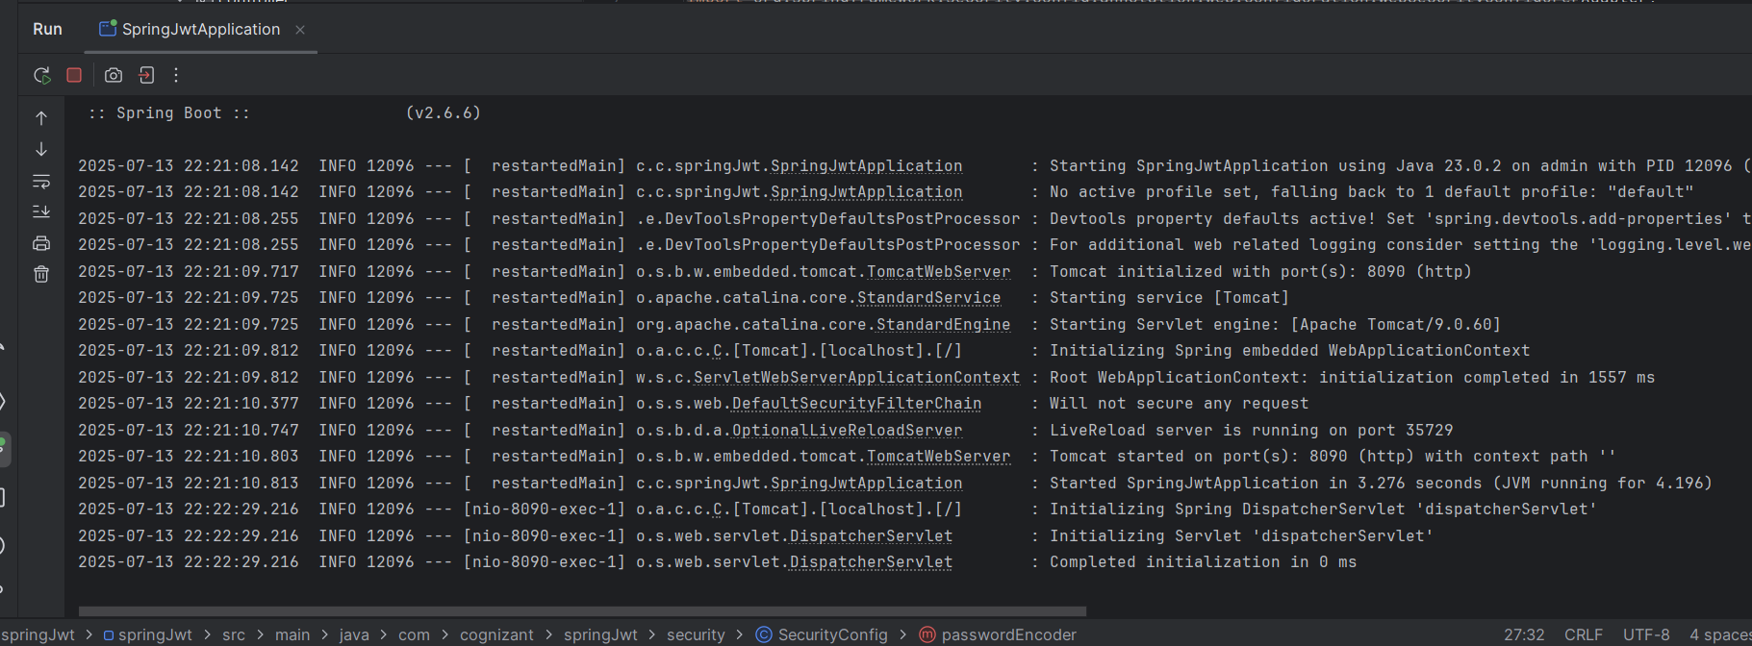**## Output**

